**awk command:**

* awk command is used for text processing and analyzing text files.
* awk name is derived from surnames of the authors who have developed awk.
* Format: awk ‘pattern {action}’ input-file > output-file
* Example: awk ‘{print $4}’ v1 > v2

This will print the element of the 4th column of each line.

* Columns are separated by space/tab (white space) by default.
* Let’s say file v25

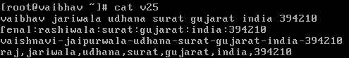

* Example: cat v25 | awk ‘{print $1}’

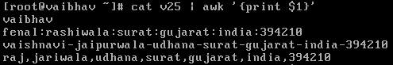

* Example: cat v25 | awk ‘{print $2}’



* Example: cat v25 | awk -F “:” ‘{print $2}’

It will separate columns by colon (:).



* Example: cat v25 | awk -F “,” ‘{print $2}’

It will separate columns by comma (,).

